**UNIVERSITY OF ELECTRONIC SIENCE AND TECHNOLOGY OF CHINA**

**School of Life Science and Technology**

**Digital Signal Processing**

FINAL REPORT

**Truly yours: Lin Jingran.**

**Have done by: Bobur Kholikov. S.I:201424090114**

****

**CHINA-2014.12.09**

Fourier Series, Fourier Transforms, and the DFT

**Introduction**

Recall from what you learned in EE207 that the input-output relationship of a linear timeinvariant (LTI) system is given by the convolution of the input signal with the impulse response of the LTI system. Recall also that computing the impulse response of LTI systems when the input is an exponential function is particularly easy. Therefore, it is natural in linear system analysis to look for methods of expanding signals as the sum of complex exponentials. Fourier series and Fourier transforms are mathematical techniques that do exactly that!, i.e., they are used for expanding signals in terms of complex exponentials. 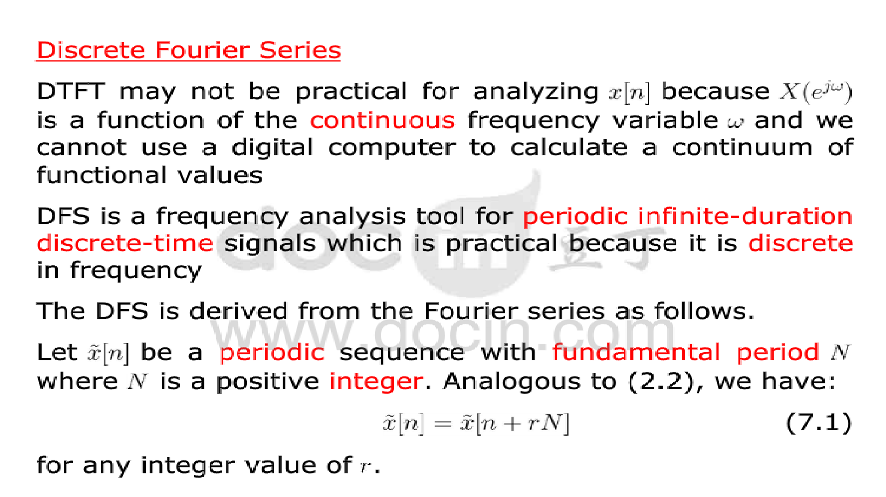

**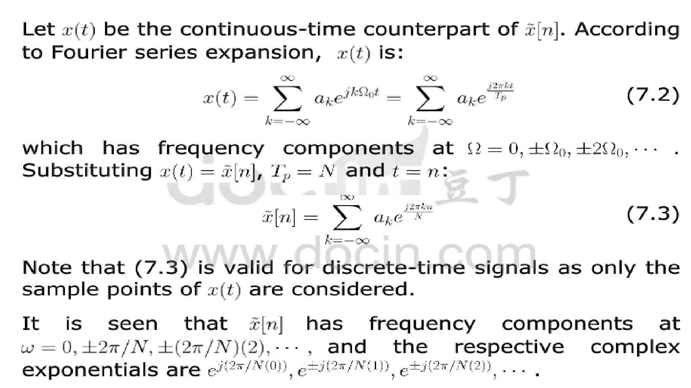**

**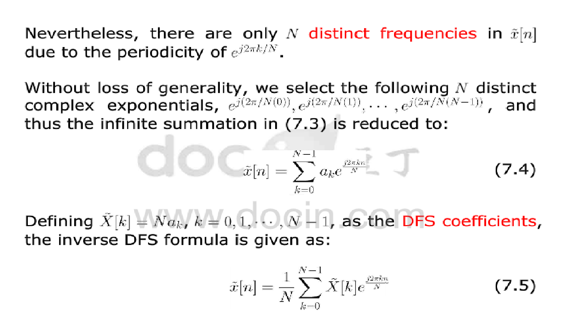**

**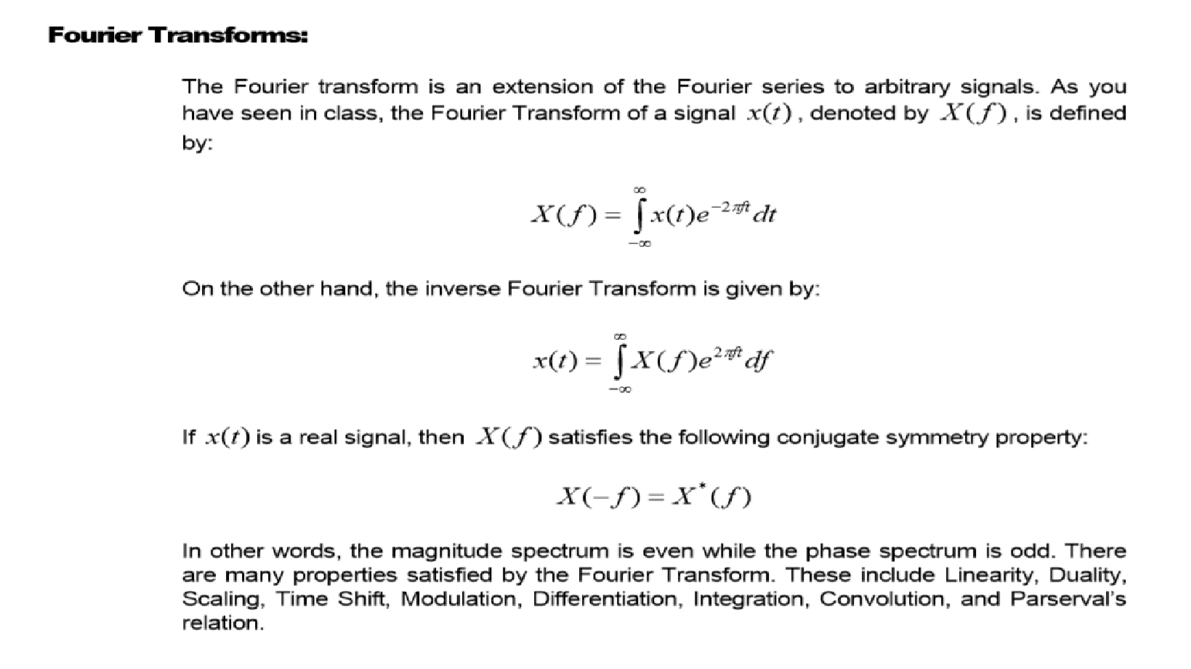**

**Relationship between the Fourier transform and Fourier series:**

A Fourier series is a sum of discrete elements, where as the fourier transform is the decomposition over a continuous set of basis functions (integral instead of summation).  How do I convert a distribution over the continuous basis set, into a sum of discrete basis functions?

Typically, you would only consider a Fourier series for a function on an interval, [-\pi,\pi]. Then the *k*th Fourier series coefficient is given by (up to a constant, it is defined differently for different disciplines, and the sign on the imaginary unit really doesn't matter as long as you are consistent)

 \int_{-\pi}^{\pi} f(x) e^{i k x} dx = \int_{-\infty}^\infty f(x) e^{i k x}dx = \mathcal{F}(k),  
  
where \mathcal{F}is the continuous Fourier transform of *f*, given by

 \mathcal{F}(\tau) = \int_{-\infty}^\infty f(x) e^{i \tau x} dx.

Similar reasoning works for periodic functions if you truncate them to one period.

**Four Fourier Representations:**

We have discussed four closely related Fourier representations.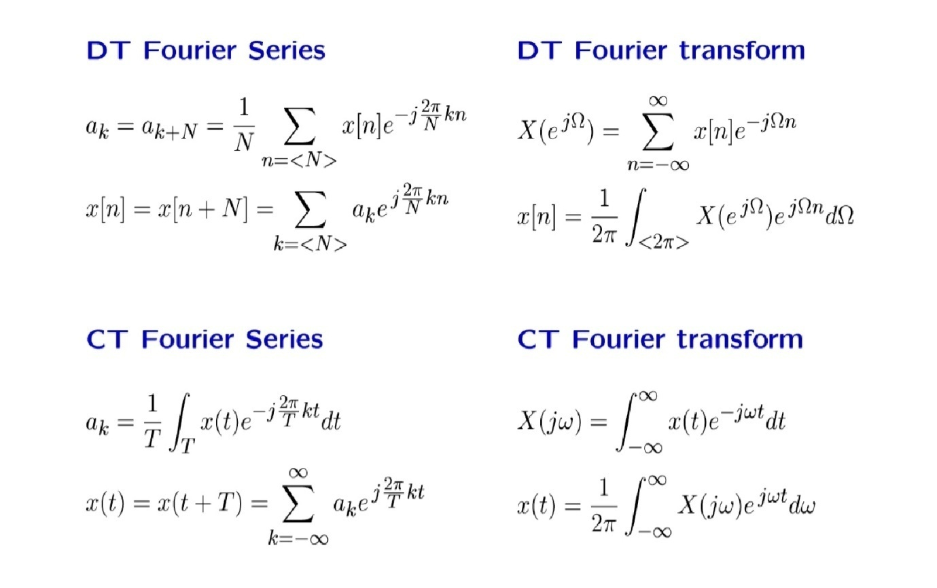

**Relations among Fourier Representations**

Explore other relations among Fourier representations. Start with an aperiodic CT signal. Determine its Fourier transform. Convert the signal so that it can be represented by alternate Fourier representations and compare.

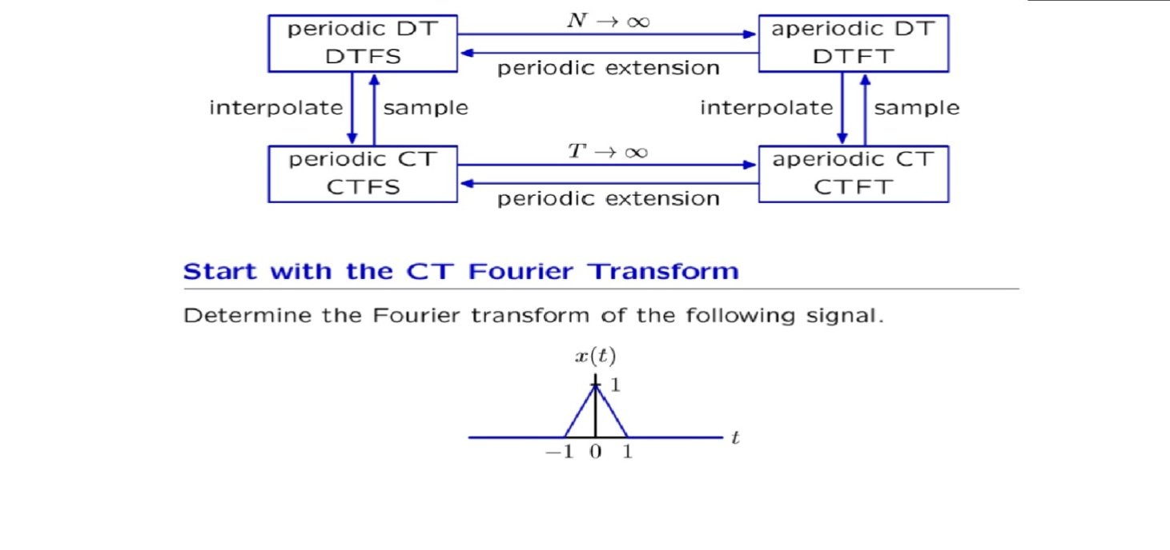

**Fourier Series Representation of Continuous Time Periodic Signals**

It is convenient to begin this discussion with the classical Fourier series representation of a periodic time do main signal, andthenderivetheFourierintegralfromthisrepresentationbyﬁndingthelimit of the Fourier coefﬁcient representation as the period goes to inﬁnity. The conditions under which a periodic signal s(t)can be expanded in a Fourier series are known as the Dirichet conditions. They require that in each period s(t) has a ﬁnite number of discontinuities, a ﬁnite number of maxima and minima, and that s(t) satisﬁes the following absolute convergence criterion

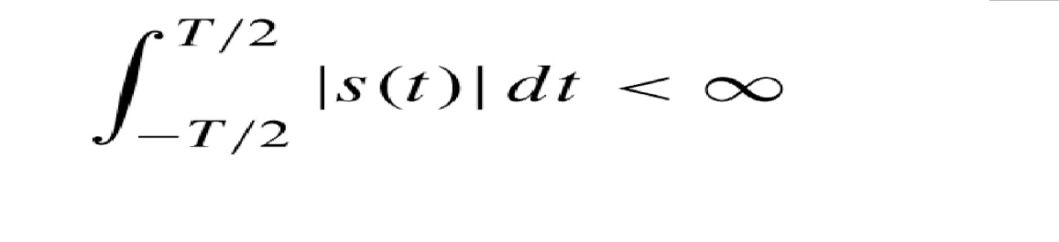

It is assumed in the following discussion that these basic conditions are satisﬁed by all functions that will be represented by a Fourier series.

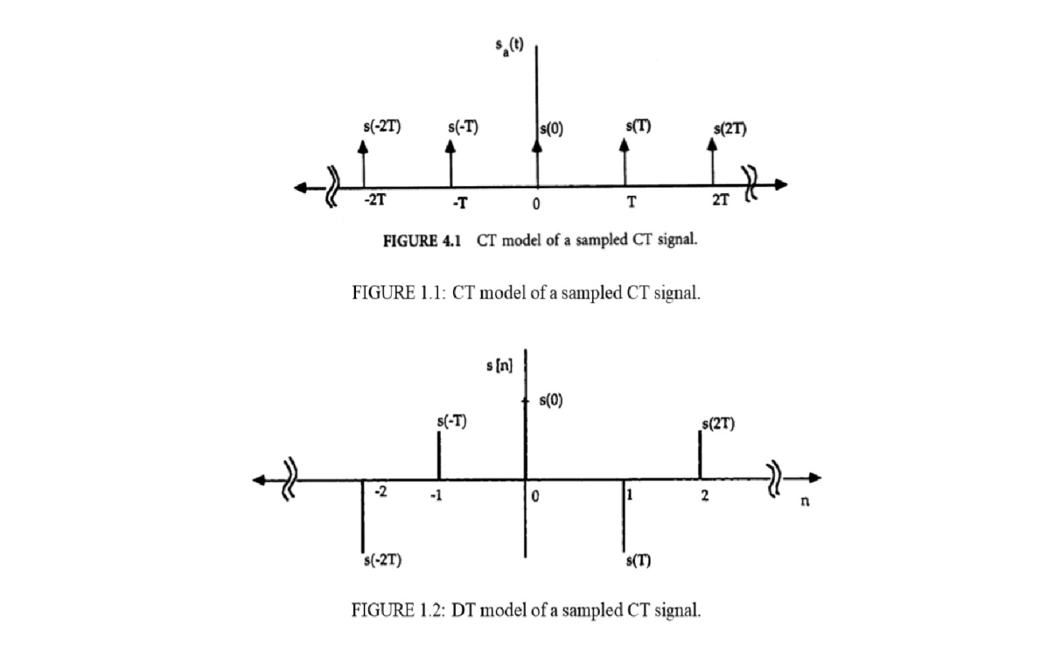

**Properties of the Continuous Time Fourier Transform**

The CTFT has many properties that make it useful for the analysis and design of linear CT systems. Some of the more useful properties are stated below. A more complete list of the CTFT properties is given in Table1.2. Proofs of these properties can be found in [2] and [3]. In the following discussion F{·} denotes the Fourier transform operation, F−1{·} denotes the inverse Fourier transform operation, and denotes the convolution operation deﬁned as

f1(t)∗f2(t) =Z ∞ −∞ f1(t −τ)f2(τ)dτ

1. Linearity (superposition): F{af1(t)+bf2(t)}=aF{f1(t)}+bF{f2(t)} (a and b, complex constants)

2. Time shifting: F{f(t−t0)}=e−jωt0F{f(t)}

3. Frequency shifting: ejω0tf(t)=F−1{F(j(ω−ω0))}

4. Time domain convolution: F{f1(t)∗f2(t)}=F{f1(t)}F{f2(t)}

5. Frequency domain convolution: F{f1(t)f2(t)}=(1/2π)F{f1(t)}∗F{f2(t)}

6. Time differentiation: −jωF(jω)=F{d(f(t))/dt}

7. Time integration: F{Rt−∞f(τ)dτ}=(1/jω)F(jω) +πF(0)δ(ω)

The above properties are particularly useful in CT system analysis and design, especially when the system characteristics are easily speciﬁed in the frequency domain, as in linear ﬁltering. Note that properties 1, 6, and 7 are useful for solving differential or integral equations. Property 4 provides the basis for many signal processing algorithms because many systems can be speciﬁed directly by their impulse or frequency response. Property3isparticularlyusefulinanalyzingcommunicationsystems in which different modulation formats a recommonly used to shift spectral energy to frequency bands these are appropriate for the application.

**The Discrete Time Fourier Transform**

The discrete time Fourier transform (DTFT) can be obtained by using the DT sampling model and considering the relationship obtained in (1.12) to be the deﬁnition of the DTFT. Letting T=1 so that the sampling period is removed from the equations and the frequency variable is replaced with normalized frequency ω0 =ωT, the DTFT pair is defined in(1.15a).Note that in order to simplify notation it is not customary to distinguish between ωandω0, but rather to rely on the context of the discussion to determine whether ω refers to the normalized (T=1) or the normalized (T6=1) frequency variable.

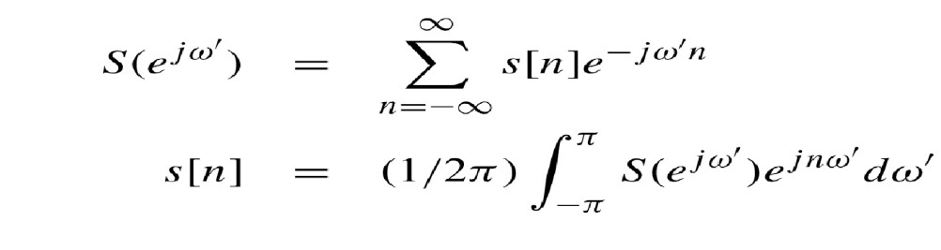

The spectrum S(ejω0) is period in ω0 with period 2π.The fundamental period in the range −π<ω 0 ≤π, sometimes referred to as the base band, is the useful frequency range of the DT system because frequency component sin this range can be represented unambiguously in sampled form (without aliasing error). In much of the signal processing literature the explicit primed notation is omitted from the frequency variable. However, the explicit primed notation will be used throughout this section because the potential exists for confusion when so many related Fourier concepts are discussed with in the same frame work. Where s[n]=s(t)t=nT . This demon strates that the spectrum of sa(t), as calculated by the CT Fourier transform is identical to the spectrum of s[n] as calculated by the DTFT. Therefore, although sa (t) and s[n] are quite different sampling models, they are equivalent in the sense that they have the same Fourier domain representation. the DTFT is a special case of the bilateralz-transform withz=ejω0t. Them or egeneral bilateralz-transform is given by

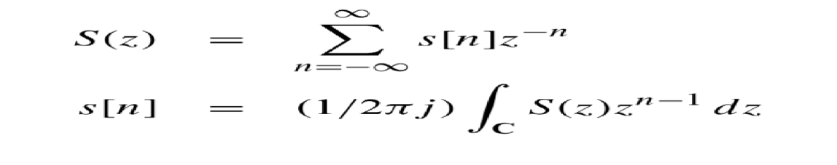

Where C is a counter clock wise contour of integration which is a closed path completely contained within the region of convergence of S(z).

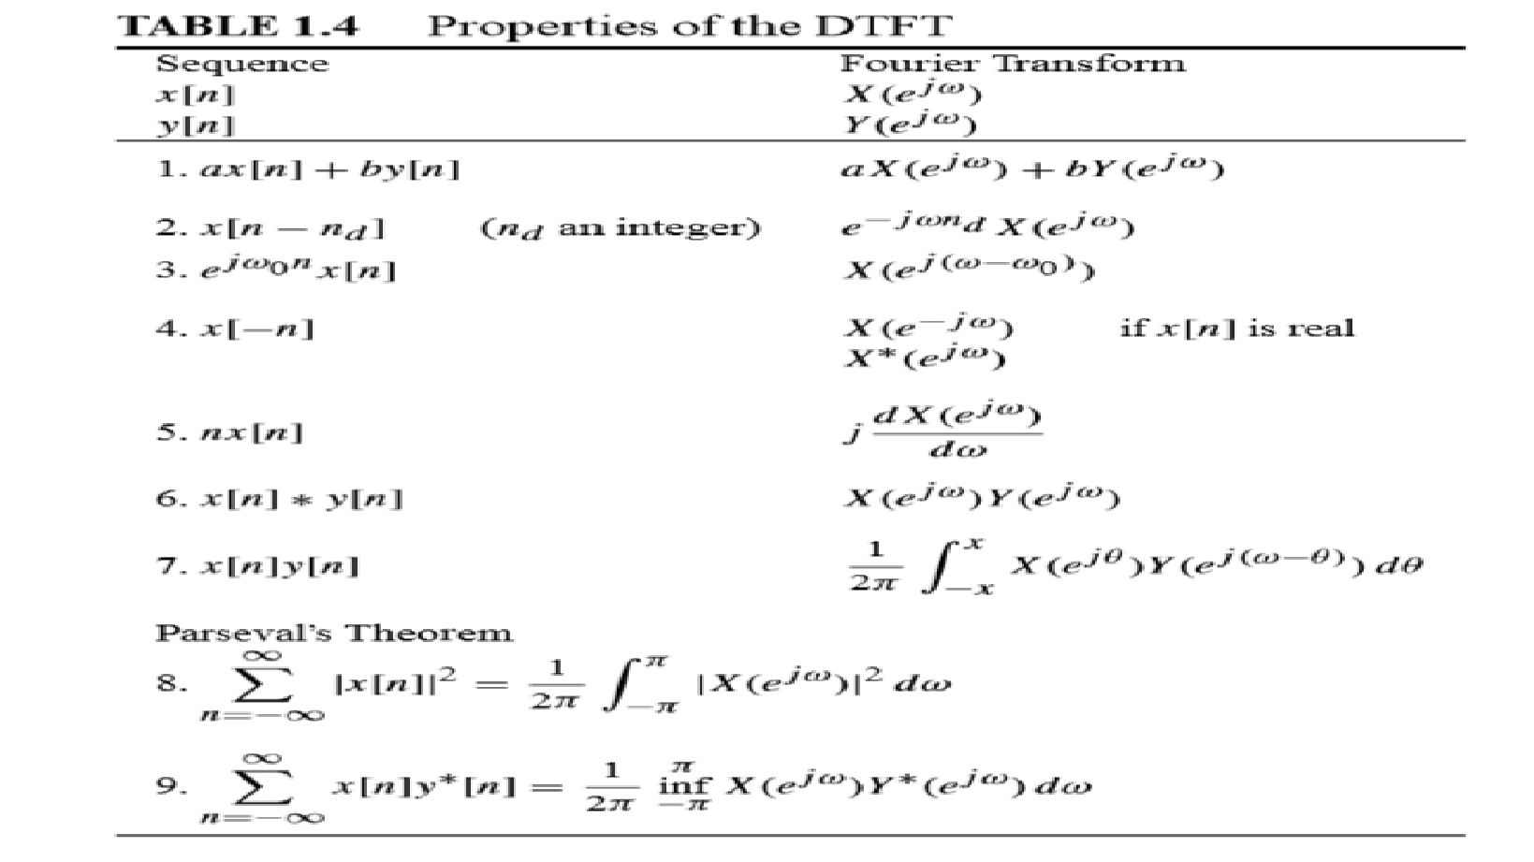

When working with DT system spractitioners must of tenmanipulate difference equations in the frequency domain. For this purpose property 1 and property 2 are very important. This is in contrast to the CTFT that is defined to have continuous time and continuous frequency domains. However, the classical Fourier series arises from the assumption that the CT signal is inherently periodic, as opposed to the time domain becoming periodic by virtue of sampling the spectrum of a continuous frequency (a periodic time) function. The dual of the DTFT , the discrete frequency Fourier transform (DFFT), has been formulated and its properties tabulated as an interesting and useful transform in its own right. These effects are obscured in the classical treatment of the CT Fourier series because the emphasis is on the inherent “line spectrum” that results from time domain periodicity. The DFFT is useful for the analysis and design of digital filters that are produced by frequency sampling techniques.

**Summary**

Emphasis was placed on illustrating how these various

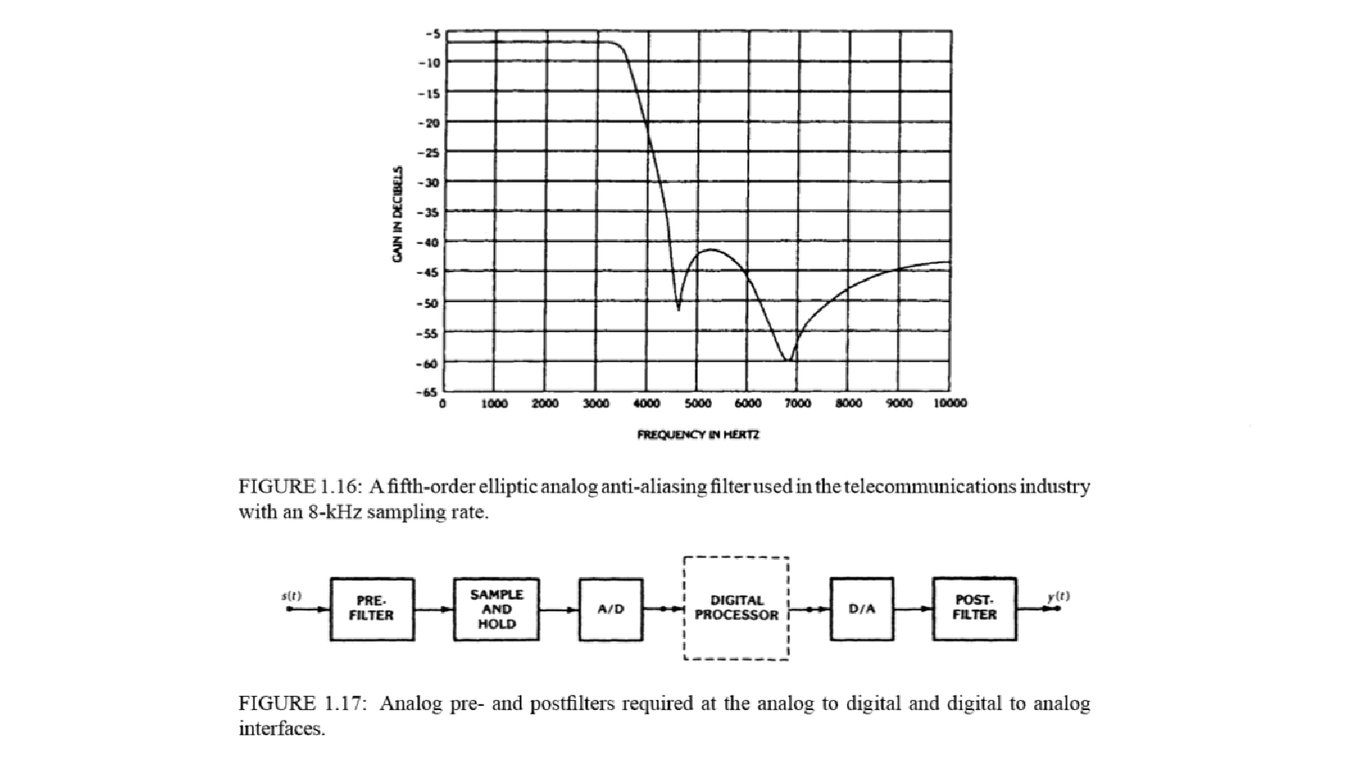

forms of the Fourier transform relate to one another, and how they are all derived from more general complex transforms, the complex Fourier (or bilateral Laplace) transform for CT, and the bilateral z-transform for DT. It was shown that many of these transforms have similar properties which are inherited from their parent forms, and that a parallel hierarchy exists among Fourier transform concepts in the CT and the DT worlds. Both CT and DT sampling models were introduced as a means of representing sampled signals in these two different “worlds,” and it was shown that the models are equivalent by virtue of having the same Fourier spectra when transformed into the Fourier domain with the appropriate Fourier transform. It was shown how Fourier analysis properly characterizes the relationship between the spectra of a CT signal and its DT counterpart obtained by sampling. The classical reconstruction formula was obtained as an outgrowth of this analysis. Finally, the discrete Fourier transform (DFT), the backbone for much of modern digital signal processing, was obtained from more classical forms of the Fourier transform by simultaneously discretizing the time and frequency domains. The DFT, together with the remarkable computational efﬁciency provided by the fast Fourier transform (FFT) algorithm, has contributed to the resounding success that engineers and scientists have experienced in applying digital signal processing to many practical scientiﬁc problems.